Lesson 1: Kʷak̓ʷala Greetings

Yo Hello
Həlakasl̓a Goodbye
Wixsas? How are you?
Wixsas x̌ʷa ǧəʔalax̌? How are you this morning?
Wixsas x̌ʷa nalax̌? How are you this day?
Wixsas x̌ʷa dᶻakʷax̌? How are you this evening?
Wixsas x̌ʷa ǧanuƛ? How are you tonight?
Həlakasm̓aw̓isλa Goodbye for now

Well wishes
ʔik la x̌us ǧəʔalax̌ Good Morning (good be your day)
ʔik la x̌us nalax̌ Good Day (good be your day)
ʔik la x̌us dᶻakʷax̌ Good Evening (good be your dusk)
ʔik la x̌us ǧanuƛ Good night (good be your night)
ʔik la x̌us mex̌ʔinē Sleep good (good be your sleep)

Wixsas? How are you?
Wixst̓əʔas And how are you?
ʔixmən I am good.
Qəlkən I am tired.
C̓əx̌q̓ən I am sick.

Masus λiǧəmos? What is your name?

ʔəngʷaxƛas. What are you called?
_______xƛən (with vowel) My name is_________.
Emilyxƛən My name is Emily.
_______ƛən (with consonant) My names is________.
Tomƛən My name is Tom.
Widas gayuƛi Where are you from

Yo X̌us λiǧəm: _______________________________

Instructions: fill in the blanks to complete each dialog. In the last section, draw and complete your own dialog

Yo  __________  Dana you might find pictures to put in these areas. | _____________  qəlkən  Find two small pictures like two people chatting. | Həlakasm̓aw̓isλa  _________________
Yo  __________ | _________________  Tomƛən | Emilyxƛən  ____________  Emily
Yo  Yo | Wixsas x̌ʷa __________?  ʔixmən | Həlakasl̓a, ʔik la x̌us  __________  Həlakas______λa

Lesson 2: Kʷak̓ʷala Numbers and Age
Mał Q̓aq̓uƛ̓adᶻəm: Hihudᶻm λu gənsʔənx̌ila

k̓iʔos 0
n̓əm 1
maʔł 2 maʔłcəmgusto 20
yudəxʷ 3 yudəxʷsəmgusto 30
mu 4 musǧəmgusto 40
sək̓a 5 sək̓asǧəmgusto 50
q̓əƛ̓a 6 q̓aƛ̓asǧəmgusto 60
ʔəλabu 7 ʔəλabusǧəmgusto 70
maʔłgʷənał 8 maʔłgʷənałcəmgusto 80
n̓an̓əm̓a 9 n̓an̓əmxsuk̓ʷa 90
laʔstu 10 lak̓ənd 100

Lasʔtu is only used in counting
nəqa is root for 10 when speaking of age, groups of, etc.

nəqaʔənx̌ila 10 years old

Las gənsʔənx̌ila? How old are you?
Lamən _______ ʔənx̌ila. I am _______ years old.

Lux̌ gənsʔənx̌ila? How old is s/he?
Lamux̌ ________ ʔənx̌ila S/he is _______ years old.

N̓əm, maʔł, yudəxʷ (Hudᶻəm) λiǧəm_______________________________

n̓əm 1 n̓əmagiʔu 11 laʔstu 10
maʔł 2 maʔłagiʔu 12 maʔłcəmgusto 20
yudəxʷ 3 yudəxʷəgiʔu 13 yudəxʷsəmgusto 30
mu 4 muwagiʔu 14 musǧəmgusto 40
sək̓a 5 sək̓agiʔu 15 sək̓asǧəmgusto 50
q̓əƛ̓a 6 q̓əƛ̓agiʔu 16 q̓əƛ̓asǧəmgusto 60
ʔəλəbu 7 ʔəλəbugiʔu 17 ʔəλəbusǧəmgusto 70
maʔłgʷənał 8 maʔłgʷənałagiʔu 18 maʔłgʷənałcəmgusto 80
n̓an̓əm̓a 9 n̓an̓əm̓agiʔu 19 n̓an̓əmsuk̓ʷa 90
laʔstu 10 maʔłcəmgusto 20 lak̓ənd 100
k̓iʔos 0 nəmaxəsi da “+” λuwi “λu”
A. Instructions: write the numeral beside each word, then solve the problem and write the answer as both a word and numeral.

1. maʔł _______ 2. yudəxʷ _______ 3. maʔłgʷənał _______
+ λu yudəxʷ _______ λu ʔəλəbu _______ λu n̓əm _______

_________ _______ ________ _______ ______________ _______

4. laʔstu _______ 5. n̓an̓əm̓a _______ 6. q̓əƛ̓a _______
- mu _______ - sək̓a _______ - maʔł _______

______________ _______ ________________ _______ ____________ _______

7. yudəxʷsəmgusto _______ 8. lak̓ənd _______ 9. q̓əƛ̓asǧəmgusto _______
λu sək̓asǧəmgusto _______ - lasʔtu _______ λu maʔłcəmgusto _______

_______________________ _______ ______________ _______ ____________________ _______

Instructions write the following phone number including area code with numerals.
maʔł, sək̓a, k̓iʔos - maʔł, maʔłgʷanał, q̓əƛ̓a - yudəxʷ, maʔł, q̓əƛ̓a, yudəxʷ

_____ _____ _____ - _____ _____ _____ - _____ _____ _____ _____

Lesson 3 (yudəxʷsa q̓aq̓uƛ̓adᶻəm)
k̓utəla fish
c̓iqʷənu egg
kusi potato
kʷənikʷ bread
ǧiwas deer
gʷadəm huckleberries
ƛ̓ina eulachon grease
q̓umis crab
k̓awas fish jerky
dᶻaxʷən eulachon

ʔəx̌ex̌sdamas ƛax̌a _________? Do you want__________?
E, ʔəx̌ex̌sdamən ƛax̌a __________. Yes, I want ____________.
K̓i, ʔisən ʔəx̌ex̌sd x̌a __________. No, I do not want__________.

Lesson 8: State of the being 1
Maʔłgʷənałc̓aq q̓aq̓uƛ̓adᶻəm: Ǧʷixstəmm̓as noqiyas sa bak̓ʷəs

pusq̓a hungry
ləmxʷa thirsty
bək̓ʷəłəla sleepy
qəlka tired
xusa rest (pause from doing)
c̓əlqʷa hot
k̓ənaʔisa cold
ławis angry
kəłəla scared
xʷəlsa missing someone, home sick
wos sad
ʔixq̓əsəla joyful

Pusq̓amox̌? Is he or she hungry?
E, pusq̓amux̌ Yes, he or is hungry.
K̓i, ʔisux̌ pusq̓a No, he or she is not hungry.

______mox̌? Is he or she ________?
E, _______mux̌. Yes, he or is _________.
K̓i, ʔisux̌ ______. No, he or she is not _________.

pusq̓a | ləmxʷa | 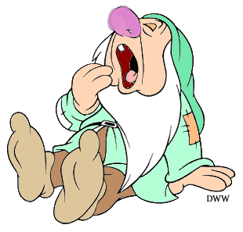  bək̓ʷəłəla
qəlka | xusa | 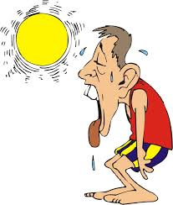  c̓əlqʷa
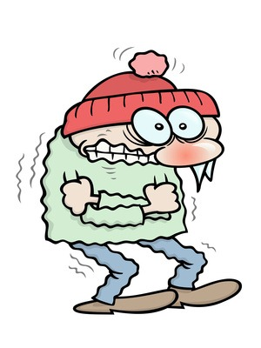  k̓ənaʔisa | ławis | kəłəla
xʷəlsa  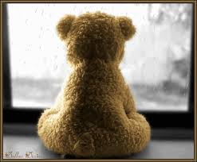 | 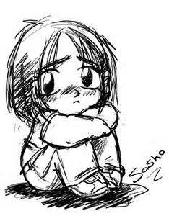  wos | ʔixq̓əsəla

ʔən k̓i, ʔisən X̌us λiǧəm: _______________________________

mən - I am k̓i, ʔisən - I am not ________maʔs? Are you_______?
Model: Pusk̓a maʔs? Pusk̓amən λu (or) k̓i, ʔisən pusk̓a

Ləmxʷa maʔs? Bək̓ʷ̌əłala maʔs?

1. ______________________________________ 2. ______________________________________

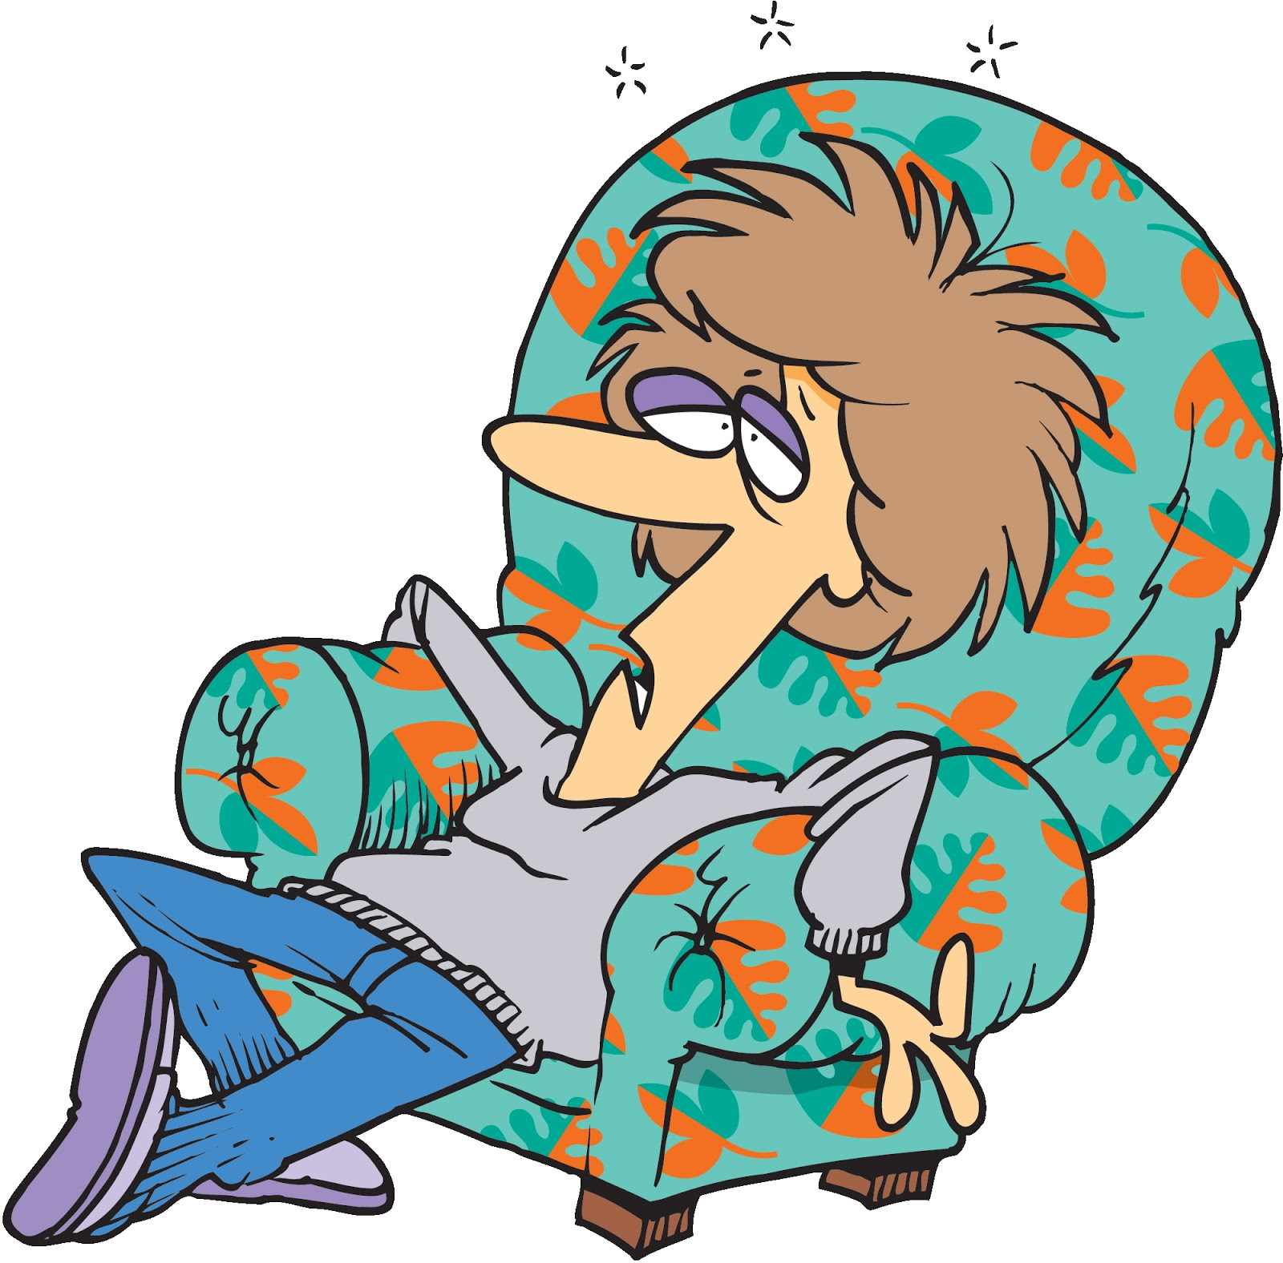 Qəlka maʔs? Xusa maʔs?

3. ______________________________________ 4. ______________________________________

C̓əlkʷa maʔs? K̓ənaʔisa maʔs?

5. ______________________________________ 6. ______________________________________

Ławis maʔs? Kəłala maʔs?

7. ______________________________________ 8. ______________________________________

Wos maʔs? ʔixq̓əsəla maʔs?

9. ______________________________________ 10. ______________________________________

